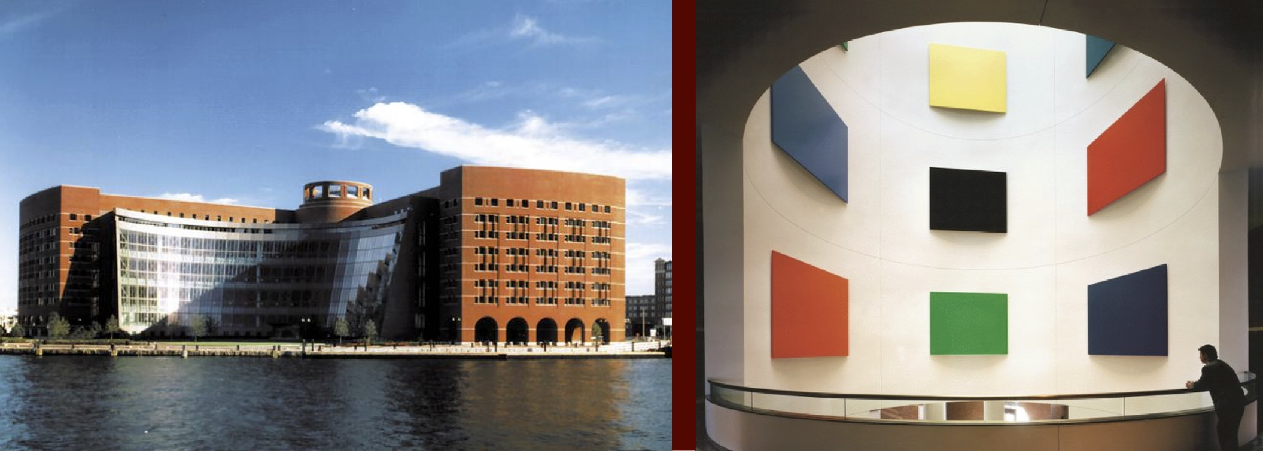
National Association of Women Artists, MA Chapter
Ellsworth Kelly’s “The Boston Panels”

'Trust the Process'
Open Themed | Non-juried
*Best of 2 works chosen by Christine Bergeron, Public Realm Director
John Joseph Moakley U.S. Courthouse, Seaport | Front, Atrium & Harbor Park Galleries

Monday, October 3, 2022 - Monday, January 2, 2023

1 Courthouse Way, Boston, MA 02210, 617.699.2736
www.nawama.org and www.moakleycourthouse.com/exhibits

Trust the Process embraces the ups and downs of the artistic course and allows our trust in our creative journey, our modus vivendi.

Mark Your Calendars:
Application and Image Submission Deadline: Sunday, September 18, 2022
Best of 2 works announced on: Monday, September 19, 2022
The arrival of Artwork: Monday, October 3, 2022, 11-1 PM [hand delivers only].
Shipped works by Sunday, October 2, 2022, email president.nawama@gmail.com for shipping details
Installation: Monday, October 3, 2022, until complete
Opening Reception: TBD
The exhibition runs: Monday, October 3, 2022 - Monday, January 2, 2023
Removal of artwork: TBD with holidays

Entry Guidelines:
-Submit up to 2 images on Smarter Entry https://client.smarterentry.com/NAWAMA
-Artwork is professionally wired for hanging and be for sale during the entire show
-In the event of a sale: 95% to the Artist, 5% to NAWAMA

Instructions:
-2-D work (no min.)
-3-D and wall-hung sculptural work (no min.)
-Pastel works must be display ready under plexiglass
-Metal or wood frames preferred. Unframed artwork must be finished on all sides.

